**Git Checkout Command**

git checkout command –

We can use checkout command to discard unstaged changed in the tracked files of working directory. (means to undo the changes from working directory to staging area)

1. Only for working directory
2. To discard unstaged changes (The changes which are not added to staging area)
3. In the tracked files (The files which are already added to staging area / commit)

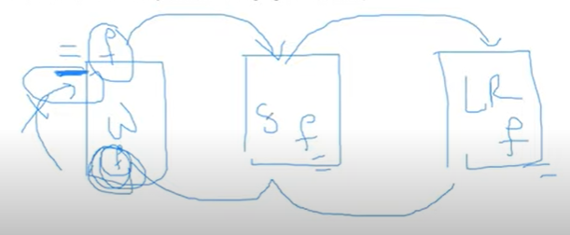

First create a file and add some lines in the file . Then add them in to the staging area and commit the changes. Then follow:

first see the file contents by the command –

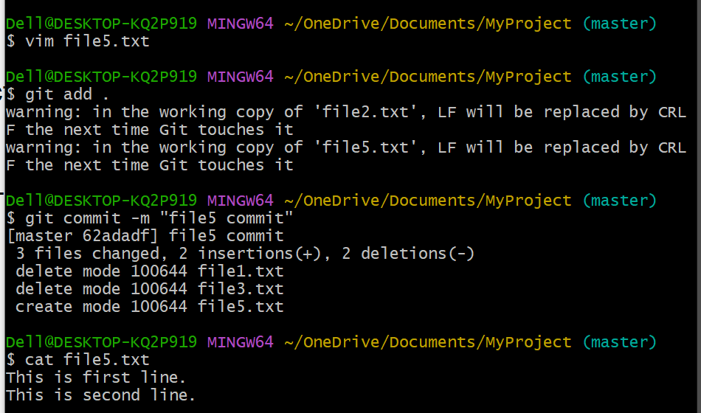$ cat file5.txt

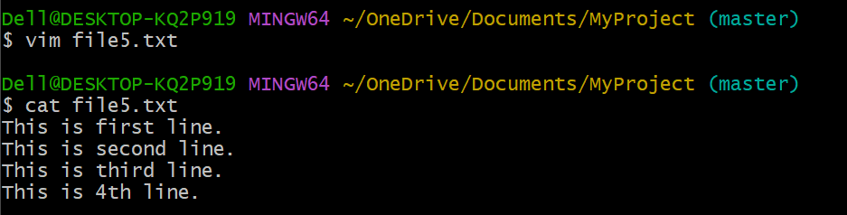Again try to add some more lines in the file by:-

Here the 3rd and 4th line are not part of staging area and local repository. So if we didn’t want these changes then we can use checkout command to undo the changes to the previous state.

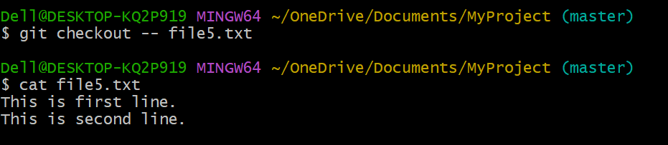Here we see ,we come to the previous state.